University of the People

MATH 1211 Calculus 1

Unit 1 Written Assignment

Anonymous Student

1. What linear function, **[ y=f(x) ](https://my.uopeople.edu/filter/tex/displaytex.php?texexp=%20y%3Df%28x%29%20)** has **[ f(0) = 8 ](https://my.uopeople.edu/filter/tex/displaytex.php?texexp=%20f%280%29%20%3D%208%20)** and **[ f(7) = 14 ](https://my.uopeople.edu/filter/tex/displaytex.php?texexp=%20f%287%29%20%3D%2014%20)**?

Accoriding to (*1.2 Basic Classes of Functions - Calculus Volume 1 | OpenStax*, n.d.)

The liner function slope can be calculate by



Thus the slope of the line is m = $\frac{14-8}{7-0}$ = $\frac{6}{7}$

And this can be written as the point-slope form

* f(x)−y1=m(x−x1)
* f(x)-8= $\frac{6}{7}$ (x)
* thus f(x)=(x)+8

2. If **[ f(t)=2t-t^2+3 ](https://my.uopeople.edu/filter/tex/displaytex.php?texexp=%20f%28t%29%3D2t-t%5E2%2B3%20)**, what is **[ \frac{f(t+h)-f(t)}{h} ](https://my.uopeople.edu/filter/tex/displaytex.php?texexp=%20%5Cfrac%7Bf%28t%2Bh%29-f%28t%29%7D%7Bh%7D%20)**?

According to the condition f(t)=2t- +3

**[ \frac{f(t+h)-f(t)}{h} ](https://my.uopeople.edu/filter/tex/displaytex.php?texexp=%20%5Cfrac%7Bf%28t%2Bh%29-f%28t%29%7D%7Bh%7D%20)** =  = = (2h+2th+h2)/h=2+2t+h

Result is 2+2t+h

3. Find all solutions to the equation **[ -4cosx=-sin^2x+1 ](https://my.uopeople.edu/filter/tex/displaytex.php?texexp=%20-4cosx%3D-sin%5E2x%2B1%20)**. Write your answer in radians in terms of **[ \pi ](https://my.uopeople.edu/filter/tex/displaytex.php?texexp=%20%5Cpi%20)**

According to (*1.3 Trigonometric Functions - Calculus Volume 1 | OpenStax*, n.d.),

**As Pythagorean identities,**

**Sin^2(theta) +Cos^2(theta) =1**

**We let x to be the radian variable, thus**

**-4 cos x = 1- sin^2x = cos2x**

Thus -4cosx = cos2x

Cosx(cosx + 4)=0

Then we get cosx=0 or cosx+4=0

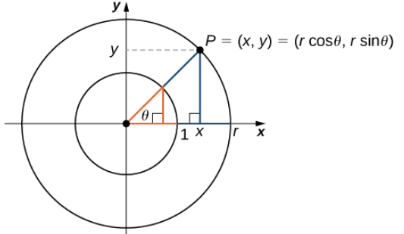

**cos θ=0 when θ = $\frac{π}{2}$ + nπ , n belong to integers** .

cos θ = - 4 not real number solution as range of f=cos(x) is [-1,1]

thus the result is **θ = $\frac{π}{2}$ + nπ , n belong to integers**

4. Sketch the graph of **[ y=3^{x+2} +5](https://my.uopeople.edu/filter/tex/displaytex.php?texexp=%20y%3D3%5E%7Bx%2B2%7D%20%2B5)**. Find the domain, range, and horizontal asymptote. Include the horizontal asymptote in your graph.

Graph as below,

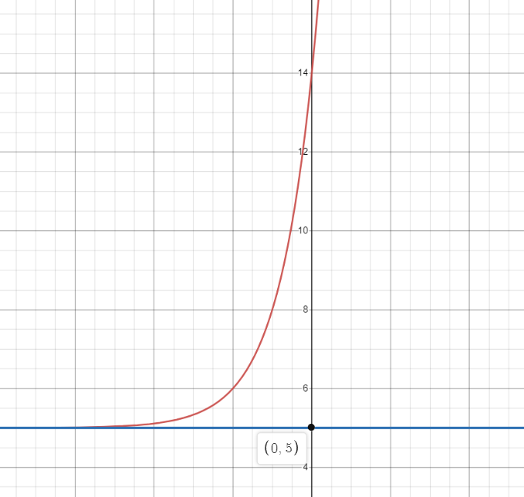

X belong to any real number thus **domain** of function is {-∞ , ∞},

3x having a range of {0, ∞} , thus the **range** of **[ y=3^{x+2} +5](https://my.uopeople.edu/filter/tex/displaytex.php?texexp=%20y%3D3%5E%7Bx%2B2%7D%20%2B5)** = {5, ∞}

The horizontal **asymptote** is y= 5 as the range is {5, ∞}.

5. Sketch the graph of **[ y= log_ 3(x+2) +5 ](https://my.uopeople.edu/filter/tex/displaytex.php?texexp=%20y%3D%20log_%203%28x%2B2%29%20%2B5%20)**. Find the domain, range, and vertical asymptote. Include the vertical asymptote in your graph.

Log3x+2

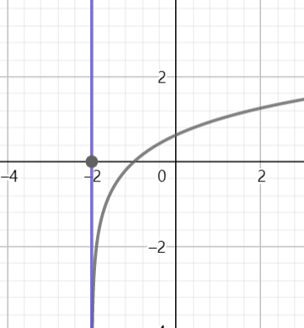

According to(1.5 Exponential and Logarithmic Functions - Calculus Volume 1 | OpenStax, n.d.),

for logarithm function , x+2 > 0 the domain (-2,∞) and range  (−∞,∞),

the vertical asymptote is when x = - 2 and range is approximate to −∞.

6. Find the domain fo the function **[ g(x)= \frac{2x}{x^2-81} ](https://my.uopeople.edu/filter/tex/displaytex.php?texexp=%20g%28x%29%3D%20%5Cfrac%7B2x%7D%7Bx%5E2-81%7D%20)**.

Since the denominator is not equal to zero,

X^2-81 != 0 , thus x2 !=81 and x!=+9 ,

thus {x|x≠+9}.

7.  From the graph below, find what is **[ f(-15) ](https://my.uopeople.edu/filter/tex/displaytex.php?texexp=%20f%28-15%29%20)** and for what numbers **[ x ](https://my.uopeople.edu/filter/tex/displaytex.php?texexp=%20x%20)** is **[ f(x)=0 ](https://my.uopeople.edu/filter/tex/displaytex.php?texexp=%20f%28x%29%3D0%20)**.

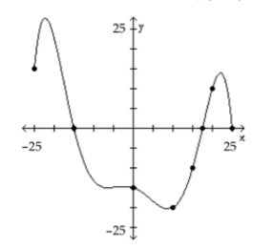

According to the graph, each unit is 5.

F(-15) have one results, at left is (-15,0).

F(0) is on y-axis (0,-15).

8.  Determine whether the graph is that of a function. If it is, use the graph to find its domain and range, the intercepts, if any, and any symmetry with respect to the x-axis, the y-axis, or the origin.

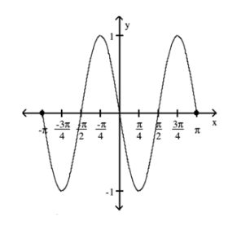

the graph is indicating a function, as for each input x there is only one value of y can be found on the graph.

The domain [-π,π] , range is [-1,1].

Y intercept is (0,0)

X intercept is (-π,0), (-π/2,0),(0,0),( π/2,0),( π,0)

For symmetry of y axis ,then need f(x)=f(-x) , as f(-π/4) != f(π/4), is not symmetry about y axis.

For symmetry of x axis, each x only have one mapping on Y axis, thus is not symmetry about x axis.

Its symmetry about the origin, as f(x)=-f(-x)

Eg . -f(-π/4) = f(π/4)

9. Determine whether the function is even, odd, or neither.

a. **[ f(x)=4x^3 ](https://my.uopeople.edu/filter/tex/displaytex.php?texexp=%20f%28x%29%3D4x%5E3%20)**

b. **[ f(x)= \frac{-x^3}{4x^2+3} ](https://my.uopeople.edu/filter/tex/displaytex.php?texexp=%20f%28x%29%3D%20%5Cfrac%7B-x%5E3%7D%7B4x%5E2%2B3%7D%20)**

c. **[ f(x)=3x^3-5 ](https://my.uopeople.edu/filter/tex/displaytex.php?texexp=%20f%28x%29%3D3x%5E3-5%20)**

1. 4(-x)3 =-4(x)3  thus is odd function.
2. –(-x)3/4(-x)2+3 = x3/4x2+3 , its odd as f(-x)=-f(x).
3. 3(-x)3-5 is not equal to f(x) and -f(x) thus its neither odd or even.

10.   A cellular phone plan had the following schedule of charges: Basic service, including 100 minutes of calls is $20.00/month; 2nd 100 minutes of calls is $0.075/minute; additional minutes of calls is $0.10/minute.

a. What is the charge for 200 minutes of calls in one month?

b. What is the charge for 250 minutes of calls in one month?

c. Construct a function that relates the monthly charge C for x minutes of calls?

1. F(200) = f1(100) +f2(100) = 20 + 0.075x100 = 20+7.5=27.5
2. F(250) = 27.5 +f3(50) = 27.5+50x0.1=32.5
3. construct a Piecewise-Defined Function

f(x) $=\left\{\begin{aligned}20 &x≤100 \\ 0.075x, 100&<x≤200 \\ 0.1x, x>200\end{aligned}\right.$

Reference

*1.2 Basic Classes of Functions - Calculus Volume 1 | OpenStax*. (n.d.). Retrieved September 5, 2022, from https://openstax.org/books/calculus-volume-1/pages/1-2-basic-classes-of-functions

*1.3 Trigonometric Functions - Calculus Volume 1 | OpenStax*. (n.d.). Retrieved September 5, 2022, from https://openstax.org/books/calculus-volume-1/pages/1-3-trigonometric-functions

*1.5 Exponential and Logarithmic Functions - Calculus Volume 1 | OpenStax*. (n.d.). Retrieved September 5, 2022, from https://openstax.org/books/calculus-volume-1/pages/1-5-exponential-and-logarithmic-functions